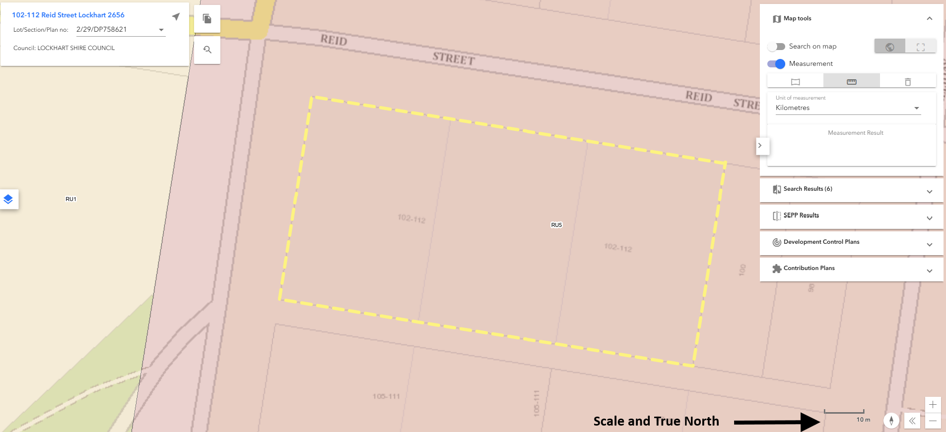Site Plan  
The plan must show the exact location of buildings and other features on the site, at the same scale as the plans and elevations. The plan must include the following details:

• north point (true north);

• scale (show ratio and bar scale), lot dimensions and areas;

• date, plan number, amendment number;

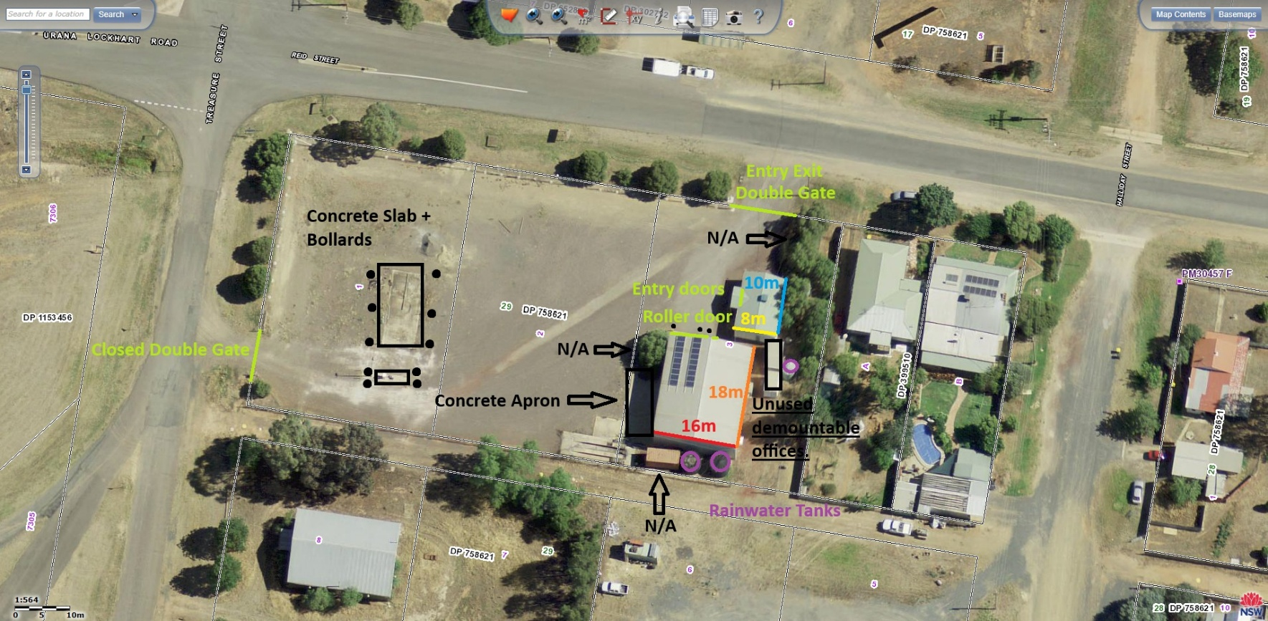• position of all existing structures, contours and spot levels  
  
N/A Indicates those trees were taken out by previous occupants

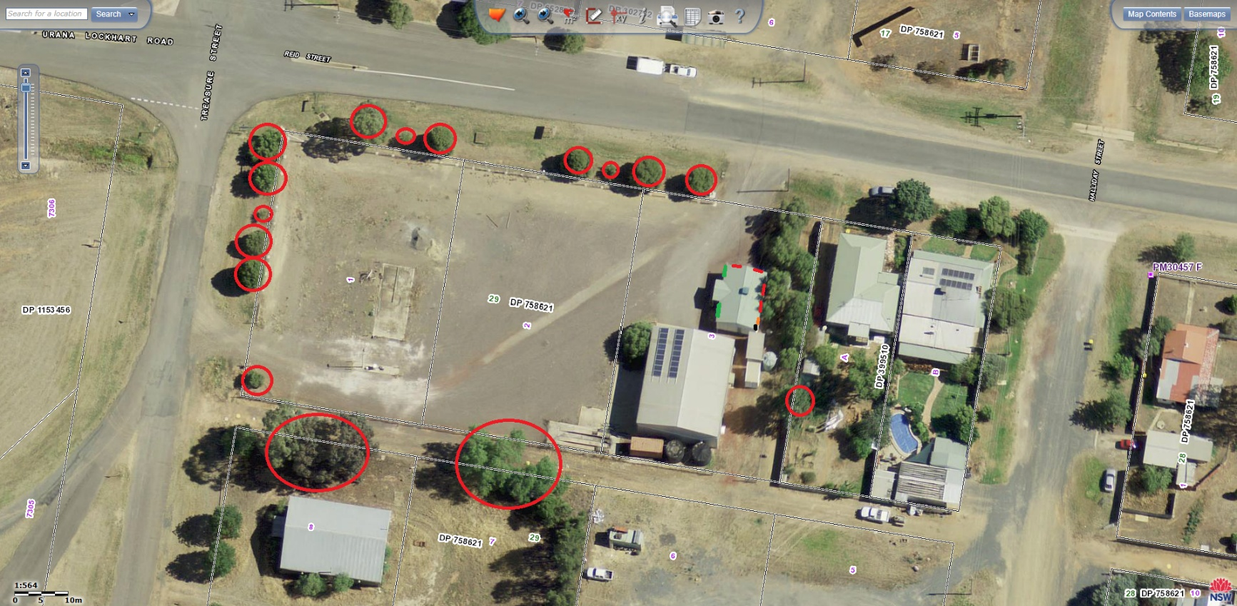• Position of structures, including trees on adjoining land (including the street and adjoining parks or open space), especially window locations in adjoining buildings with top and bottom of sill heights;

Window Locations and top and bottom sill heights.

Front, West Facing = Green : Bottom 1120mm Top 2220  
Side, North Facing = Red : Bottom 1120mm Top 2220  
Rear, East Facing = Red : Bottom 1120mm Top 2220  
Rear, Kitchenette, East Facing = Orange : Bottom 1320mm Top 2220  
Rear, Bathroom, East Facing = Black : Bottom 1620mm Top 2220

• the location and levels of any solar panels on adjoining lots.

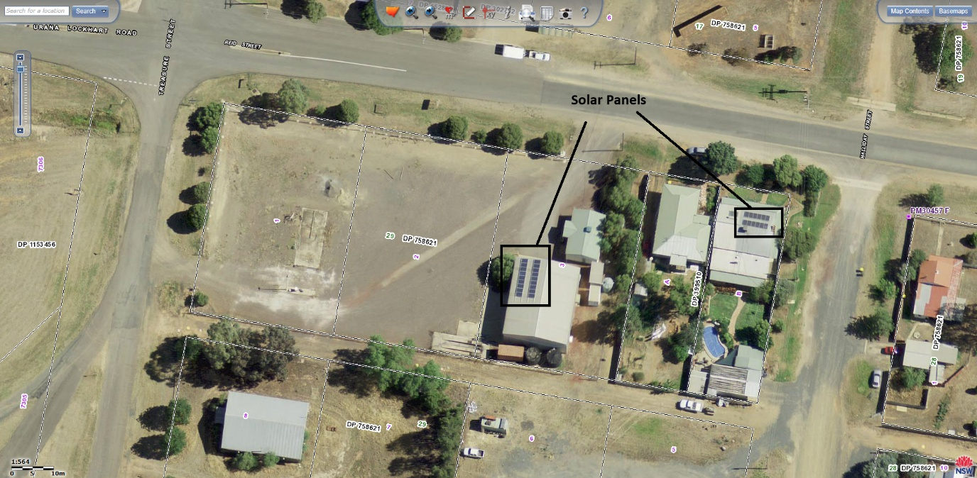

Please ensure that your document includes the following before uploading

a. The location, boundary dimensions, site area and north point of the land.

b. Existing vegetation and trees on the land.   
One Tree Site in Sth W Corner -35.2273335, 146.7107866.

c. The location and uses of existing buildings on the land.

Demountable Site Office.  
-35.2271812  
146.7117845  
  
Storage Shed.  
-35.2273350  
146.7116789

Unused Demountable Offices.  
-35.2272862  
146.7118228

d. existing levels of the land in relation to buildings and roads.

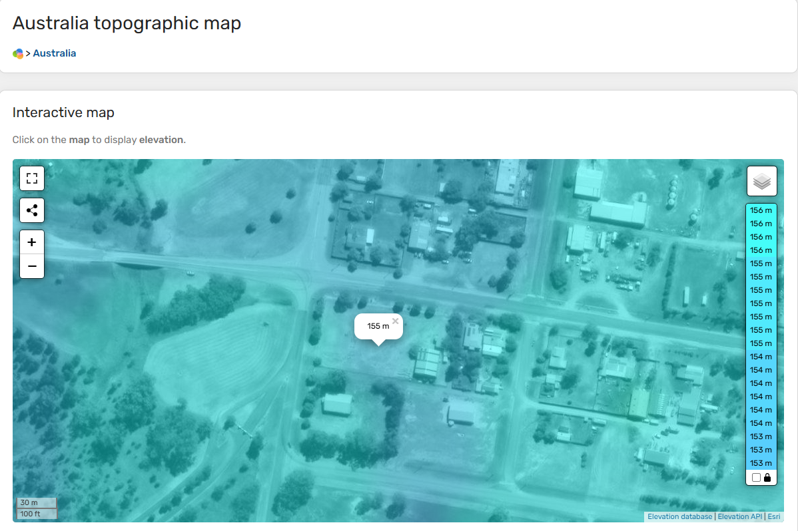

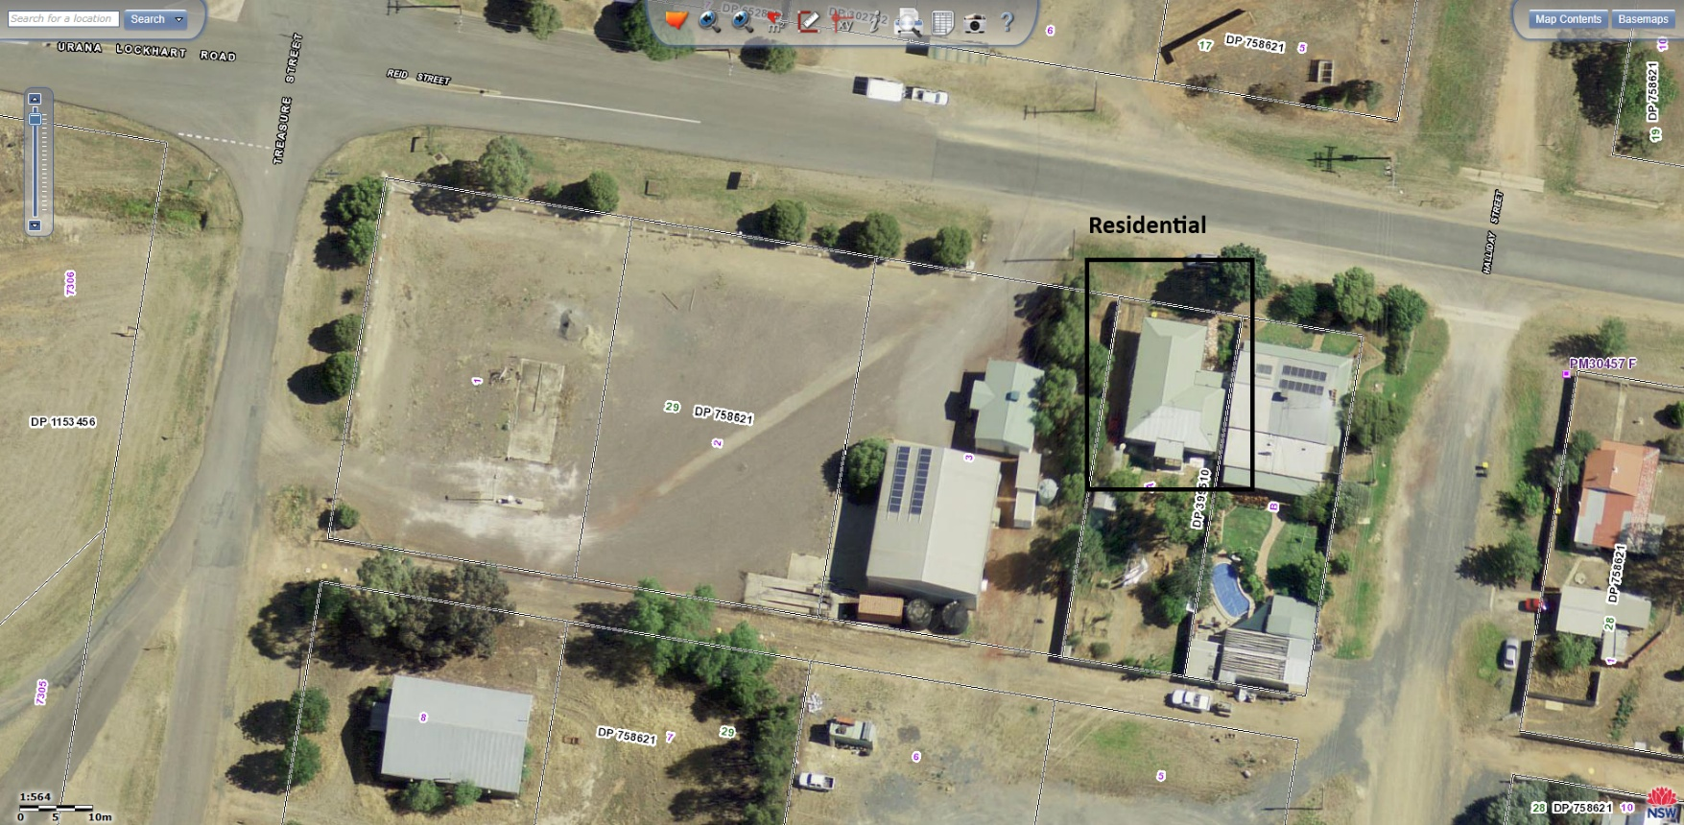e. the location and uses of buildings on sites adjoining the land.

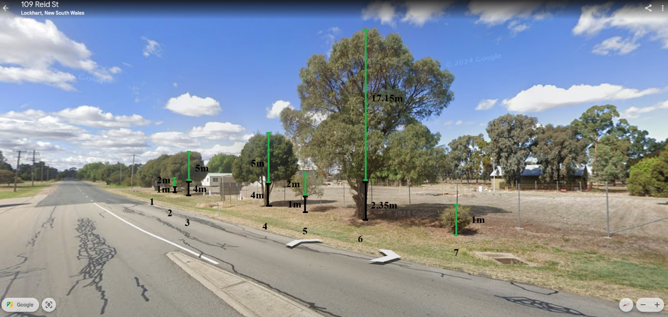

• Position of existing trees on both the site and adjoining sites (including the street and adjoining parks or open space), and reduced level at the base of such trees, and their height and canopy spread;

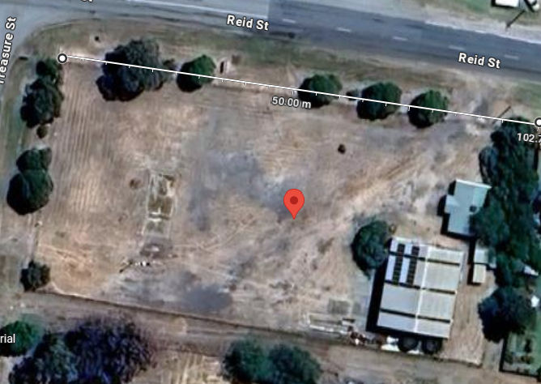1 - 8m Width  
-35.2270070  
146.7117042

2 – 8m Width  
-35.2269882  
146.7115826

3 – 1.5m Width  
-35.2269694  
146.7115248

4 – 8m Width  
-35.2269584  
146.7114535

5 – 2m Width  
-35.2269266  
146.7111727

6 – 12m Width  
-35.2269184  
146.7110925

7 – 1m Width  
-35.2268858  
146.7109400

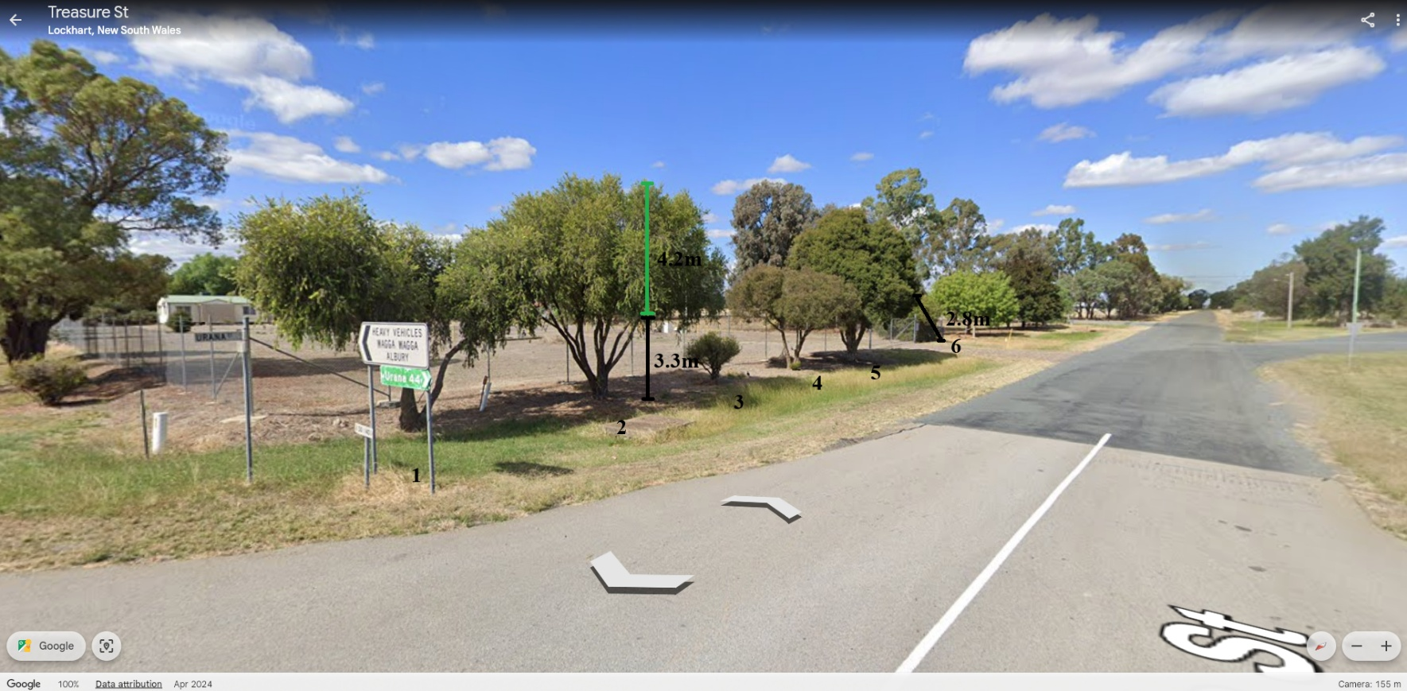1 – 8m Width  
-35.2269233  
146.7108070

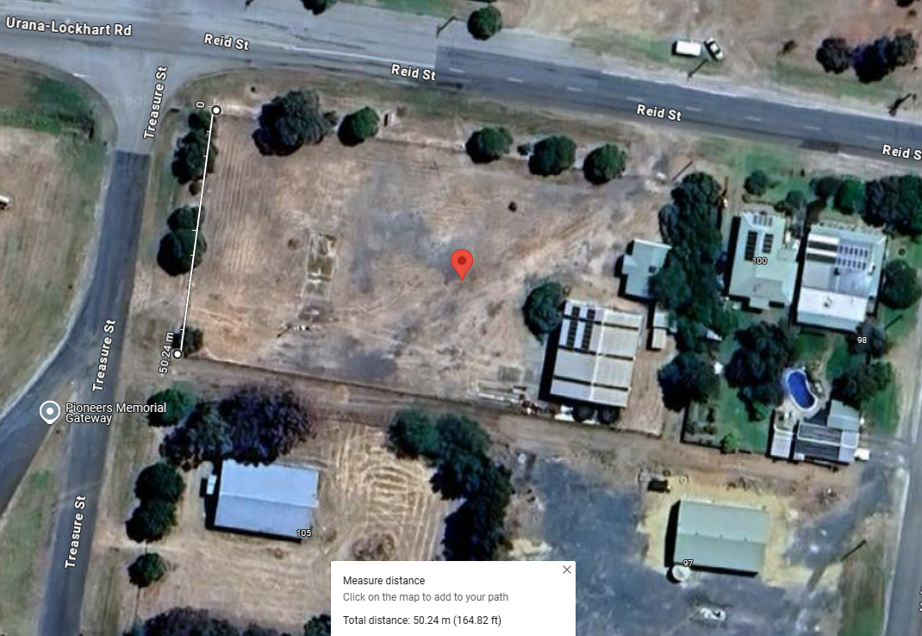2 – 8m Width  
-35.2269541  
146.7107998

3 – 1.5m Width  
-35.2270071  
146.7107946

4 – 6m Width  
-35.2270989  
146.7107675

5 – 8m Width  
-35.2271561  
146.7107578

6 - 5m Width  
-35.2273335  
146.7107866